|  |  |  |  |  |  |  |  |  |  |
| --- | --- | --- | --- | --- | --- | --- | --- | --- | --- |
| **SCHOOL OF COMPUTER SCIENCE AND ARTIFICIAL INTELLIGENCE** | | | | | **DEPARTMENT OF COMPUTER SCIENCE ENGINEERING** | | | | |
| **Program Name:** B. Tech | | | | **Assignment Type: Lab** | | | **Academic Year:**2025-2026 | | |
| **Course Coordinator Name** | | | | Venkataramana Veeramsetty | | | | | |
| **Instructor(s) Name** | | | | |  | | --- | | Dr. V. Venkataramana (Co-ordinator) | | Dr. T. Sampath Kumar | | Dr. Pramoda Patro | | Dr. Brij Kishor Tiwari | | Dr.J.Ravichander | | Dr. Mohammand Ali Shaik | | Dr. Anirodh Kumar | | Mr. S.Naresh Kumar | | Dr. RAJESH VELPULA | | Mr. Kundhan Kumar | | Ms. Ch.Rajitha | | Mr. M Prakash | | Mr. B.Raju | | Intern 1 (Dharma teja) | | Intern 2 (Sai Prasad) | | Intern 3 (Sowmya) | | NS_2 ( Mounika) | | | | | | |
| **Course Code** | | | 24CS002PC215 | **Course Title** | | AI Assisted Coding | | | |
| **Year/Sem** | | | II/I | **Regulation** | | R24 | | | |
| **Date and Day**  **of Assignment** | | | Week7 - Thursday | **Time(s)** | |  | | | |
| **Duration** | | | 2 Hours | **Applicable to**  **Batches** | |  | | | |
| **AssignmentNumber:13.1**(Present assignment number)/**24**(Total number of assignments) | | | | | | | | | |
|  | | | | | | | | | |
|  | **Q.No.** | **Question** | | | | | | ***Expected Time***  ***to complete*** |  |
|  | 1 | **Lab 13: Code Refactoring – Improving Legacy Code with AI Suggestions**  **Lab Objectives:**   * Identify code smells and inefficiencies in legacy Python scripts. * Use AI-assisted coding tools to **refactor** for readability, maintainability, and performance. * Apply **modern Python best practices** while ensuring output correctness.   **Task 1**   * **Task:** Refactor repeated loops into a cleaner, more Pythonic approach.   **Instructions:**   * Analyze the legacy code. * Identify the part that uses loops to compute values. * Refactor using **list comprehensions** or helper functions while keeping the output the same. **Legacy Code:**   numbers = [1, 2, 3, 4, 5]  squares = []  for n in numbers:  squares.append(n ** 2)  print(squares)  **Expected Output:**  [1, 4, 9, 16, 25]  **Task 2**  **Task:** Simplify string concatenation. **Instructions:**   * Review the loop that builds a sentence using +=. * Refactor using " ".join() to improve efficiency and readability. **Legacy Code:**   words = ["AI", "helps", "in", "refactoring", "code"]  sentence = ""  for word in words:  sentence += word + " "  print(sentence.strip())  **Expected Output:**  AI helps in refactoring code  **Task 3**  **Task:** Replace manual dictionary lookup with a safer method. **Instructions:**   * Check how the code accesses dictionary keys. * Use .get() or another Pythonic approach to handle missing keys gracefully. **Legacy Code:**   student_scores = {"Alice": 85, "Bob": 90}  if "Charlie" in student_scores:  print(student_scores["Charlie"])  else:  print("Not Found")  **Expected Output:**  Not Found  **Task 4**  **Task:** Refactor repetitive if-else blocks. **Instructions:**   * Examine multiple if-elif statements for operations. * Refactor using **dictionary mapping** to make the code scalable and clean. **Legacy Code:**   operation = "multiply"  a, b = 5, 3  if operation == "add":  result = a + b  elif operation == "subtract":  result = a - b  elif operation == "multiply":  result = a * b  else:  result = None  print(result)  **Expected Output:**  15  Top of Form **Task 5**  **Task:** Optimize nested loops for searching. **Instructions:**   * Identify the nested loop used to find an element. * Refactor using Python’s in keyword or other efficient search techniques. **Legacy Code:**   items = [10, 20, 30, 40, 50]  found = False  for i in items:  if i == 30:  found = True  break  print("Found" if found else "Not Found")  **Expected Output:**  Found | | | | | | Week7 - Thursday |  |

**Task 1**

* **Task:** Refactor repeated loops into a cleaner, more Pythonic approach.

**Instructions:**

* Analyze the legacy code.
* Identify the part that uses loops to compute values.
* Refactor using **list comprehensions** or helper functions while keeping the output the same.  
  **Legacy Code:**

numbers = [1, 2, 3, 4, 5]

squares = []

for n in numbers:

squares.append(n ** 2)

print(squares)

**Expected Output:**

[1, 4, 9, 16, 25]

Prompt:Refactor repeated loops into a cleaner, more Pythonic approach.

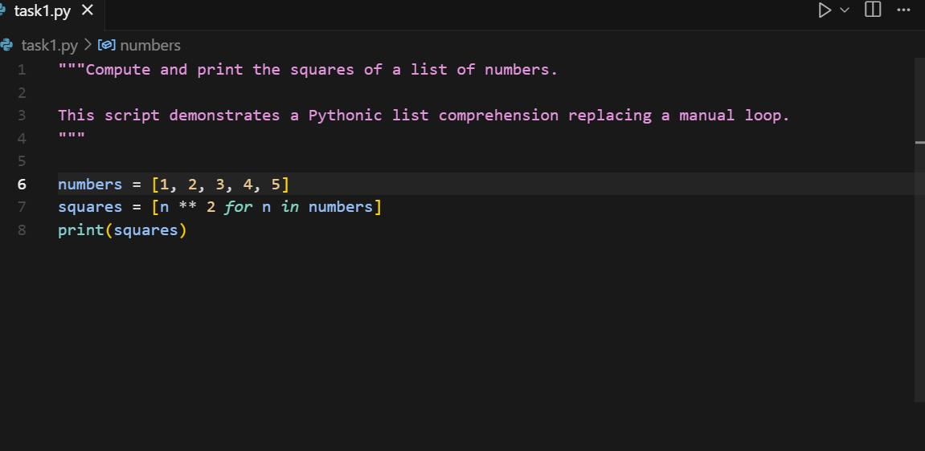

Output:

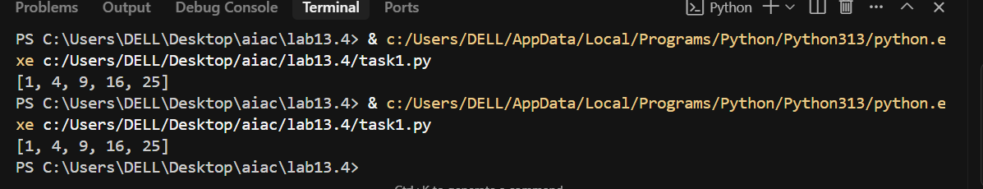

**Task 2**

**Task:** Simplify string concatenation.  
**Instructions:**

* Review the loop that builds a sentence using +=.
* Refactor using " ".join() to improve efficiency and readability.  
  **Legacy Code:**

words = ["AI", "helps", "in", "refactoring", "code"]

sentence = ""

for word in words:

sentence += word + " "

print(sentence.strip())

**Expected Output:**

AI helps in refactoring code

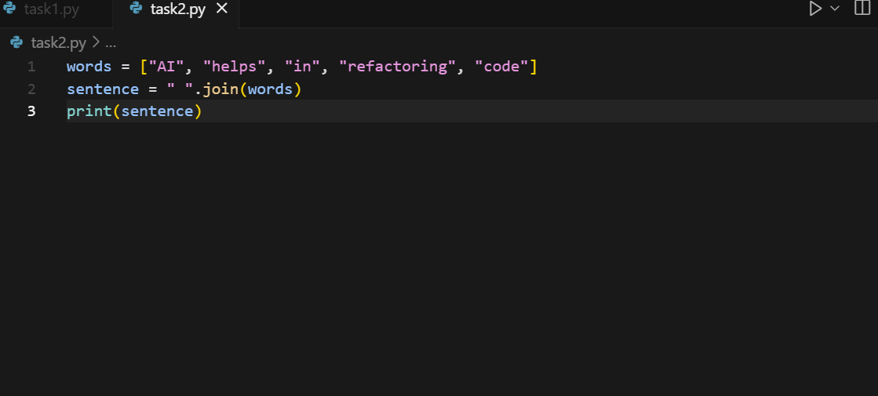

Output:

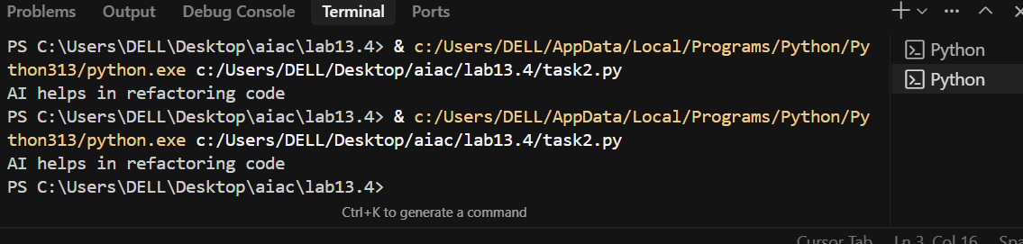

**Task 3**

**Task:** Replace manual dictionary lookup with a safer method.  
**Instructions:**

* Check how the code accesses dictionary keys.
* Use .get() or another Pythonic approach to handle missing keys gracefully.  
  **Legacy Code:**

student_scores = {"Alice": 85, "Bob": 90}

if "Charlie" in student_scores:

print(student_scores["Charlie"])

else:

print("Not Found")

**Expected Output:**

Not Found

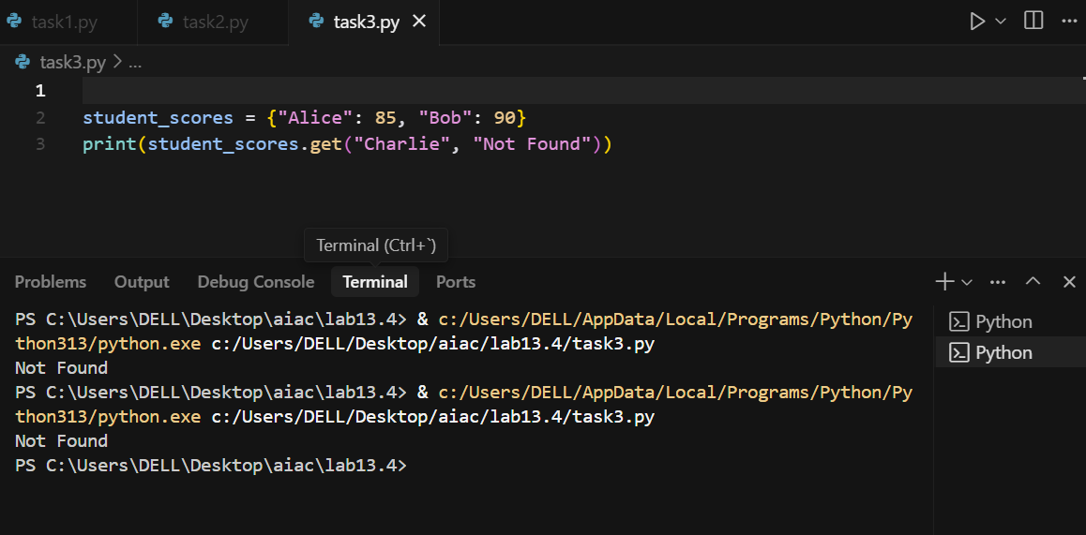

**Task 4**

**Task:** Refactor repetitive if-else blocks.  
**Instructions:**

* Examine multiple if-elif statements for operations.
* Refactor using **dictionary mapping** to make the code scalable and clean.  
  **Legacy Code:**

operation = "multiply"

a, b = 5, 3

if operation == "add":

result = a + b

elif operation == "subtract":

result = a - b

elif operation == "multiply":

result = a * b

else:

result = None

print(result)

**Expected Output:**

15

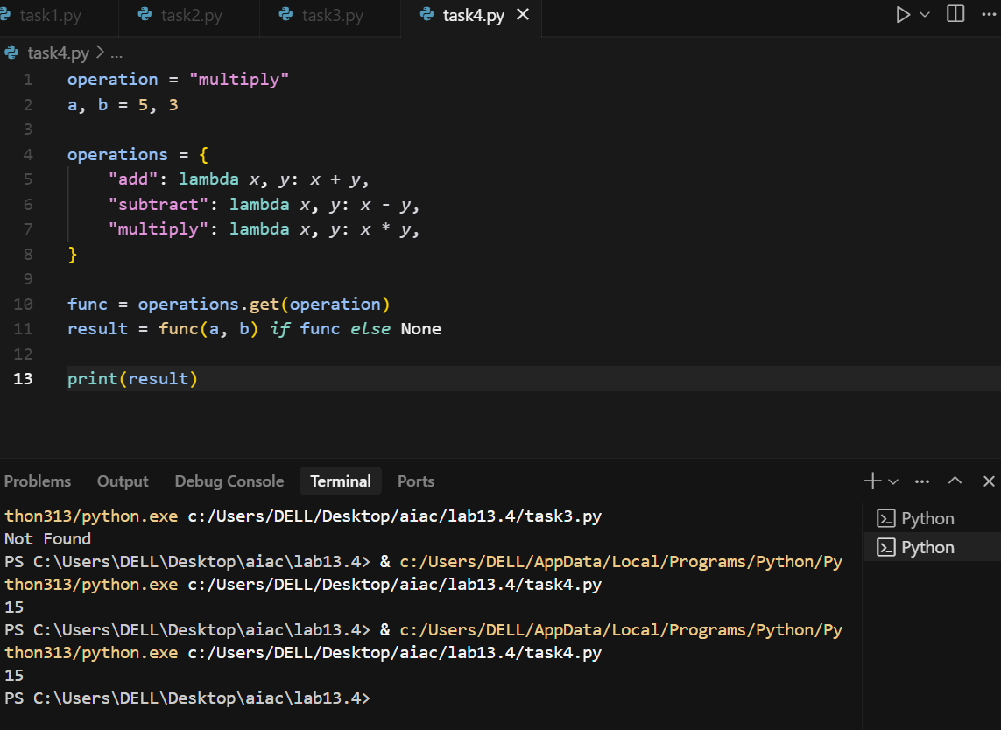

Top of Form **Task 5**

**Task:** Optimize nested loops for searching.  
**Instructions:**

* Identify the nested loop used to find an element.
* Refactor using Python’s in keyword or other efficient search techniques.  
  **Legacy Code:**

items = [10, 20, 30, 40, 50]

found = False

for i in items:

if i == 30:

found = True

break

print("Found" if found else "Not Found")

**Expected Output:**

Found

